# SP-6 Red Time Mileage Tracker (w GPS)

Senior Project, Section 2, Fall 2024, 08/27/2024, Professor Sharon Perry

## Project Team

| **Roles** | **Name** | **Major responsibilities** | **Contact (Cell Phone)** |
| --- | --- | --- | --- |
| Team Leader | David Lowe | Documentation; ensure that all deliverables are submitted on time. | 678-901-5606 |
| Team members | Lloyd Anderson | Documentation | 678-818-9349 |
| Parth Patel | Developer | 706-936-1255 |
| Ryan Thompson | Developer | 678-575-3461 |
| Humberto Aguilar Sanchez | Developer | 770-527-7705 |
| Advisor / Instructor | Sharon Perry | Facilitate project progress; advise on project planning and management. | 770-329-3895 |

| Parth Patel  Developer | Lloyd Anderson  Documentation | Ryan Thompson  Developer |
| --- | --- | --- |
| David Lowe  Team Leader | Humberto Aguilar Sanchez  Developer |

## Project Overview / Abstract (Research)

The Time Mileage Tracker with GPS is a mobile app that enables all employers to ensure employees are efficiently managing time and mileage. Employers can access data on employees’ activities to verify time and mileage reports. The app aims to improve productivity, reduce user input errors, and provide accurate records for employers.

## 2.0 Project website

www.mileagetracker.com

## Deliverables

* Project plan draft
* Requirements
* Design
* Prototype design
* Final report and presentation
* Final product
* (optional use tutorial)

## Milestone Events

* Planning documentation complete - September 1, 2024
* Concept design complete - September 15, 2024
* Prototype Complete - October 1, 2024
* Prototype presentation - October 15, 2024
* C Day - November 19, 2024
* Application fully developed - December 2, 2024
* Final report - December 2, 2024

## Meeting Schedule Date/Time

Bi-weekly status meetings on Thursdays from 4:15 pm to 4:30 pm.

## Collaboration and Communication Plan

Weekly Discord meetings on Mondays and Wednesdays at 4:00pm.

Text message communication in group chat.

## Project Schedule and Task Planning

See the Project Work Plan (Gantt chart) file attached.

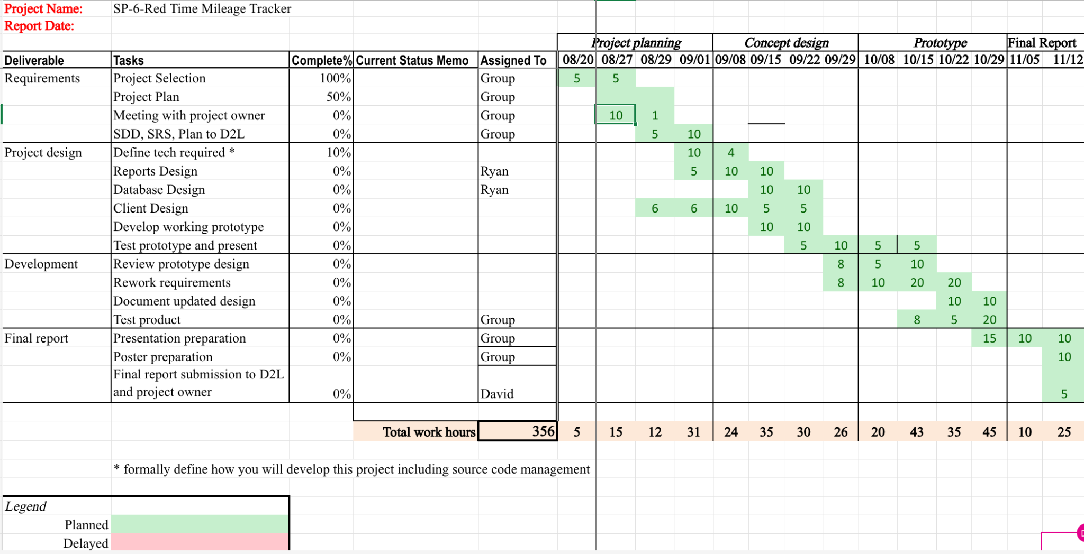

## Version Control Plan

Deploy each milestone onto GitHub and update along the way.

## Tutorial Plan

Record a demo video that demonstrates how to use the application for first time users.